Active Directory is a directory service developed by microsoft to manage windows domain Networks.It stores information related objects such as computers and users.Authenticates using kerbros tickets.Non-windows devices can authenticate via LDAP and RADIUS   
  
How kerberos Works   
  
  
  
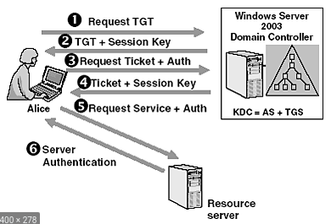  
Benefits of Active Directory  
  
  
single point of access for network resources  
Hierarchical organisational structure   
  
Componets of Active Directory   
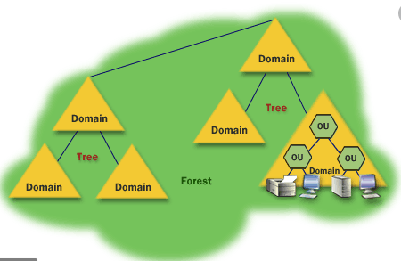  
  
  
Physical components of Active Directory  
1.Domain controller   
Server with the AD DS role installed that has been promoted to domain controller   
-Hosts a copy AD DS directory store   
-Provide authentication and authorization services   
-Replicates updates to other domain controllers in the domain and forest   
-Allows administrative access to manage user accounts and network resouces   
  
  
2.AD DS data store   
Contains the database files and processes that store and manage directory information for users,services and applications   
-Consists ofthe Ntds.dit file   
-Stored by default in the %systemRoot%\NTDS folder on all domain controllers   
-Accessible only through the domain controller processes and protocals   
-Ntds file also consists of the password hashes for all the users   
  
  
  
  
  
Logical Componets of Active Directory   
  
AD DS schema   
Defines objects that can be created in the active directory  
  
  
Domains  
  
Used to group and manage objects in organisatons   
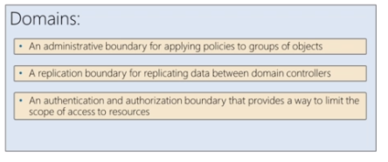  
  
Trees   
A hierachy of domains   
  
Forest  
A collection of one or more domain trees   
  
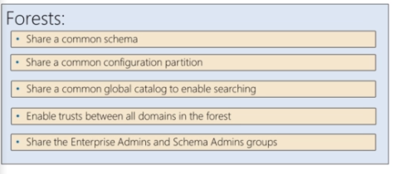  
  
Organisational units (OUs)  
Containers that can contain users,groups,computers and other OUs   
  
Trusts   
Provide a mechanism for users to gain access to resources in another domains  
  
Objects   
  
